Book title: Essential Procedures for the Emergency, Urgent, & Primary Care Settings: A Clinical Companion 4th edition

Section:

Chapter #: 54

Chapter title: Hip Dislocation

Corresponding Author: Jamal Hussain

Jamal Hussain, MD, ABEM

Program Director

Capital Health Emergency Medicine Residency

Pennington, New Jersey

1 Capital Way

Pennington, NJ 08534

Phone: (609)303-4010

jhussain@capitalhealth.org

ORCID Identifier: 0000-0003-1531-3854

<metadata>

**KEY WORDS**: hip dislocation; orthopedic emergency

**ABSTRACT**: Hip dislocation is an orthopedic emergency. It is essential to reduce the hip as soon as possible to minimize various long-term complications, such as avascular necrosis, chronic arthritis, and long-term nerve injury. Hip dislocations require significant force. Be aware of additional injuries. While there are more than 20 reduction techniques, this chapter covers the more well-known and novel reduction methods.

</metadata>

**CHAPTER 54**

Hip Dislocations

*Jamal Hussain*

**<H1>BACKGROUND**

The ball-and-socket hip joint is one of the most stable in the body. The acetabulum of the pelvis creates the socket, and the head of the femur forms the ball. This allows the femur to rotate freely through a 360-circle and to swivel around its axis 90 degrees. Dislocation of the hip is an orthopedic emergency and represents 5% of all joint dislocations. When managing hip dislocations, the two keys to highlight are <bold>**time</bold>** and <bold>**energy</bold>**: specifically, the time to reduction and the amount of energy which caused the dislocation. Delayed reduction is associated with multiple long-term sequelae. Prosthetic hip dislocations are more common, require less force and occur from simple daily activities. Reduction is urgent in these prosthetic cases, but <bold>***in native cases they are emergent as the initial development of avascular necrosis can begin in as little as 6 hours.</bold>*** Pediatric hips have more laxity than adult hips and can dislocate with ground-level injuries.

**<H2>ANATOMY AND PHYSIOLOGY**

The femoral head is deeply seated in the acetabulum. The articular surface of the acetabulum encapsulates more than 80% of the femoral head. (Figure 54.1) The ball-and-socket joint, along with the ligamentous attachments, the labrum and the strong musculature of the upper thigh and gluteal region, provides joint stability. The sciatic nerve rests behind the femoroacetabular joint. Note, the blood supply to the hip is important in understanding potential sequalae of dislocation in the native hip regarding potential avascular necrosis (AVN). The deep femoral artery (off of the common femoral artery) is the parent vessel of the <bold>***medial circumflex femoral artery (MFCA), which supplies most of the blood to the***[***femoral head***](https://www.google.com/search?client=safari&sca_esv=1cd912c63e8479c3&cs=0&q=femoral+head&sa=X&ved=2ahUKEwiHja6OitOPAxVNSzABHWYzKncQxccNegQIAxAB&mstk=AUtExfCsVSoan7V9txktVFHBApeyMvn4CsmiIGOT-KonBLVvSp0OmUUvT0RadguFxt678cdZlL1mnS_64kOjPc4ZwqXY4zWQ_AWpBgBvXBw_otv3qJgH10WtgfX20JSG7qPn7LA&csui=3) ***and neck.*** This critical arterial supply is well affixed to the femoral neck and is easily damaged with any displaced femoral neck fracture. ***During a hip dislocation, the deep branch of the MFCA can be stretched, kinked, or torn, disrupting the blood flow to the femoral head. This disruption can lead to AVN (bone necrosis) of the femoral head starting in as little as 6 hours, making prompt reduction of the dislocation crucial to restoring blood flow in the native hip*** (Figure 54.2).</bold>

**<H2>SPECIFIC PATHOLOGIES**

**<H3>Types of Dislocations**

There are 4 types of hip dislocation:<bold> **posterior, anterior, central, and inferior**. </bold>

1. Posterior dislocations are the most common, accounting for 90% of cases. They commonly occur from front-end motor vehicle collisions (**FIGURE 54.3**). Either the knee hits the dashboard, forcing the femoral head posteriorly, or there may be significant axial loading from the floorboard against an extended extremity. Other mechanisms include falls from heights, industrial accidents, sports injuries, and auto versus pedestrian mishaps.
2. Anterior dislocations make up 10% of cases. Mechanism of injury includes forceful extension, abduction, and external rotation, similar to removing a drumstick.
3. Central dislocations are rare, comprising only 2-4%. They are similar to posterior dislocations with extension of the femoral head through the center of the acetabulum.
4. Inferior dislocations, also known as luxatio erecta femoris, are extremely rare and occur when the femoral head is forced downwards, below the acetabulum.

**<H1>PATIENT PRESENTATION**

***<bold>Native hip dislocations are high-energy injuries with approximately a 95% rate of associated injuries, most commonly fractures of the acetabulum and femoral head, and traumatic injuries to other body parts like the head, chest, and knee.</bold>*** A thorough physical exam is critical. Studies describe variable coexisting injury rates involving the head (24–32%), thorax (21–65%), and extremities (33–100%). <bold>Pay particular attention to the acetabulum and ipsilateral knee which can have occult injuries in 93% even without signs of injury. </bold>

These injuries often occur in motor vehicle collisions, which can also cause damage to the surrounding hip and thigh structures. It is critical to apply [ATLS principles](https://www.google.com/search?client=safari&sca_esv=adba07b31be7c891&cs=0&q=ATLS+principles&sa=X&ved=2ahUKEwiXwdy2idiPAxU9SjABHQxVLFoQxccNegQIQRAB&mstk=AUtExfAXeE4AsARMzx2LlEDeDBmuZgnj1k6qIv_VBLKxKXMlZkeiEmPK9qbHoqtHbbIrCBa05VG489PfEzxwmUPKMe8LCItQgOFor_oehuy6CkaJwjw7w1IuyXwM5IEbh4tagfI&csui=3) regarding thoroughness and respect to such high energy injuries to identify all associated injuries. Nerve injuries, especially to the sciatic nerve, can also occur with the long-term potential of foot drop. It is critical to perform a thorough medical assessment such as using [ATLS principles](https://www.google.com/search?client=safari&sca_esv=adba07b31be7c891&cs=0&q=ATLS+principles&sa=X&ved=2ahUKEwiXwdy2idiPAxU9SjABHQxVLFoQxccNegQIQRAB&mstk=AUtExfAXeE4AsARMzx2LlEDeDBmuZgnj1k6qIv_VBLKxKXMlZkeiEmPK9qbHoqtHbbIrCBa05VG489PfEzxwmUPKMe8LCItQgOFor_oehuy6CkaJwjw7w1IuyXwM5IEbh4tagfI&csui=3) to identify all associated injuries. In <bold>**posterior hip dislocations,</bold>** the leg is shortened, adducted, and internally rotated with the hip and knee held in slight flexion (Figure 54.4). Note how the affected knee points toward the opposite knee.

In cases of anterior dislocations, theleg is externally rotated, abducted, and extended at the hip (Figure 54.5). In this case, the knee is pointing away from the opposite knee.

*Remember, posterior dislocations prefer (P) the opposite knee and anterior dislocations are away (A). Posterior = Prefer. Anterior = Away*.

In posterior dislocations, you may palpate the femoral head sitting in the gluteal area and in the femoral triangle with anterior dislocations.

**<H1>TREATMENT**

Prioritize hemodynamic instability and life-threatening injuries. Then administer analgesics even prior to plain radiography. A standard pelvis x-ray is often sufficient for the diagnosis, but consider additional views based on mechanism of injury or suspicion for concurrent injuries (Figure 54.6).

Plain films help differentiate the type of dislocation. Assess the size of the femoral head and the prominence of the lesser trochanter. In posterior dislocations, the femoral head lies closer to the film and further from the generator in standard anterior-posterior plain films, Therefore, the femoral head appears smaller. Conversely, the femoral head appears larger with anterior dislocations because it lies closer to the generator. (**see** Figure 54.7).

In posterior dislocations, the femur is internally rotated obscuring the lesser trochanter. However, with anterior dislocations, the femur is externally rotated making the lesser trochanter appear more prominent. A lateral view helps delineate anterior versus posterior displacement of the femoral head and facilitates identifying subtle fractures.

Computed tomography (CT) imaging is more sensitive for detecting additional injures, but do not delay reduction to obtain these.

**<H1>Contraindications and Relative Contraindications**

* Unstable patients requiring resuscitation / emergent surgery
* Large femoral neck, shaft, or pelvic fracture(s), significant ipsilateral knee injury. Note that not all femoral head and neck fractures preclude reduction.
* Prosthetic joints, especially 3-4 months post-operatively
  + Discuss with orthopedics prior to reduction attempt.
* Pediatric dislocations
  + Discuss with orthopedics prior to reduction attempt.

**<H1>SPECIAL CONSIDERATIONS**

**<H2>PROSTHETIC HIP DISLOCATIONS**

The number of total hip arthroplasty (THA) procedures has increased recently. Prosthetic hips are much less stable and often dislocate from trivial activity. In fact, orthopedists warn patients that simple movements, including crossing one’s leg, arising from a seated position, or turning in bed, can dislocate the hip. Prosthetic hip dislocations are reported in 0.2% to 5% of primary THA procedures. Recurrent dislocations may require a revision. Nonetheless, dislocations can occur in up to 10% of revisions. (**FIGURE 54.8**).

In prosthetic hips, posterior displacement occurs in 90% of cases and typically within 3-4 months post-operatively. Consider orthopedic consultation with all prosthetic hip dislocations, given emergent reductions are typically unnecessary and may cause further damage and instability to the prosthesis.

**<H2>PEDIATRIC HIP DISLOCATIONS**

Pediatric hips have more pliability and laxity, and the acetabulum may be more retroverted. For these reasons, it dislocates from less force, including ground-level activities. Sports injuries account for most dislocations in younger children. Motor vehicle accidents account for the majority in teenagers with 50% of dislocations presenting with concurrent injuries. Time to reduction is critical. In fact, Mehlman et al. (2000) demonstrated a 20-fold increased risk avascular necrosis (AVN) with reductions occurring more than six hours post-injury. Beware of physeal injuries. Closed reduction may further damage the physes and cause epiphyseal detachment. Consult a pediatric orthopedist prior to any reduction attempt as reduction under general anesthesia reduces the risk of.

**<H1>PROCEDURE PREPARATION**

The keys to success are adequate analgesia and controlled gradual reduction. Generally, we recommend procedural sedation for hip reductions. However, ultrasound-guided regional anesthesia provides an alternative with appropriately trained providers. Document neurovascular status before and after reduction.

**<H1>PROCEDURE**

**<H2>techniqueS**

Be facile with multiple reduction techniques, given none are 100% successful. Beware of the potential complications of each method. Avoid positioning that puts you, the clinician, at risk of injury.

For posterior dislocations, most reduction techniques involve the following hip maneuvers:

1. Flexion
2. Internal rotation
3. Adduction

Note, for anterior dislocation, there are 2 subtypes based on location of the femoral head. Pubic dislocations cannot be flexed. They require a combination of:

1. Extension
2. In-line traction
3. External rotation

Obturator dislocations require:

1. Flexion
2. Adduction
3. External Rotation

In all cases, an assistant can facilitate by pushing on the femoral head or pulling the femur laterally.

**<H3>Techniques for Posterior Dislocations**

Existing literature describes nearly twenty different methods. We describe the most common methods for posterior hip dislocation (90%).

* Allis maneuver
* Whistler
* Captain Morgan
* Howard
* Bigelow maneuver
* Piggyback/Rocket Launcher

***<H4>Allis Technique***

The Allis technique is the most common hip reduction technique utilized(Figure 54.9andVideo 54.1).

* Place the patient in the supine position.
* An assistant faces the clinician and provides pelvic stabilization by pushing posteriorly on the bilateral anterior superior iliac spine (ASIS). Do not allow the pelvis (acetabulum) to move during femoral head (ball) repositioning.
* The clinician stands on the bed, facing the patient, and places both hands behind the knee/calf of the affected side, lifting the femur anteriorly.
* Position the knee and hip in 90 degrees of flexion.
* Apply steady, constant traction anteriorly with simultaneous, gentle internal and external rotation of the femur.
* The assistant can apply lateral traction on the proximal femur.
* After successful reduction, extend the hip while maintaining traction.
* 60% success rate (Walden & Hamer, 1999).

***<H4>Whistler Technique***

* Place the patient in the supine position (Figure 54.10andVideo 54.2).
* An assistant faces the clinician and provides pelvic stabilization by pushing posteriorly on the bilateral anterior superior iliac spine (ASIS). Do not allow the pelvis (acetabulum) to move during femoral head (ball) repositioning.
* The clinician stands on the affected side, facing the long axis of the stretcher, and places their forearm under the 120-degree flexed, ipsilateral knee while the same hand grasps the 90-degree flexed contralateral knee.
* Using the other hand, the clinician grasps the affected ankle and, firmly pushing toward the bed, stabilizes the ipsilateral leg.
* The clinician, using constant and firm force, raises their arm, which subsequently applying an anterior force to the affected knee, raising the femur anteriorly.
* The importance of grasping and affixing the affected ankle cannot be overemphasized.
* Slight internal and external rotation of the affected hip, using the forearm as a fulcrum under the affected knee, may facilitate increased success.
* 64% successful reduction rate (Walden & Hamer, 1999).

***<H4>Captain Morgan Technique***

* Place the patient in the supine position (Figure 54.11 andVideoS 54.3 A and B).
* An assistant faces the clinician and provides pelvic stabilization by pushing posteriorly on the bilateral anterior superior iliac spine (ASIS). Do not allow the pelvis (acetabulum) to move during femoral head (ball) repositioning.
* The clinician stands perpendicular to the patient on the affected side and places a flexed knee on the stretcher under the patient’s ipsilateral knee and places their foot close to the hip (analogous to the illustration of the infamous rum icon). Then the clinician places one hand under the patient’s ipsilateral knee and the other hand over the patient’s ipsilateral ankle.
* Flex the patient’s affected knee and hip to 90 degrees and, on the unaffected side, maintain hip and knee extension.
* Apply upward, axial force in the direction of the femur via the clinician’s knee by flexion of the clinician’s calf muscle/plantar flexion. Internally and externally rotate the ipsilateral hip with the patient’s ankle as needed.
* Maintain the patient’s knee in 90-degree flexion. Applying a slight downward pressure on the patient’s ankle may be needed.

***<H4>Bigelow Maneuver***

* Place the patient in the supine position (Figure 54.12andVideo 54.4).
* The clinician grasps the ankle of the affected leg with one hand and places their opposite forearm under the patient’s knee.
* Flex the hip to 90 degrees, keeping the affected leg in an adducted and internally rotated position.
* While an assistant stabilizes the pelvis with posterior pressure, the clinician applies traction in line with the femur while abducting, externally rotating, and extending the ipsilateral hip.
* The Bigelow method is utilized less often given case reports of increased femoral neck fractures in those patients with traumatic hip dislocation.

***<H4>Howard Maneuver***

* Place the patient in the supine position (Figure 54.13andVideo 54.5).
* The clinician and an assistant stand on the side of the affected hip.
* Flex the affected hip and knee at a 90-degree angle.
* An assistant applies lateral traction on the thigh of the affected side while helping to stabilize the pelvis.
* Another assistant should apply downward force on the patient’s bilateral ASIS for stabilization of the acetabulum.
* The clinician holds the affected lower leg by grasping the popliteal fossa and ankle and then applies traction in line of the femur while inducing internal and external rotation until reduction occurs.

***<H4>Piggyback/Rocket Launcher Technique***

* Place the patient in the supine position with the buttocks at the edge of the bed. (Figure 54.14andVideo 54.6).
* Flex the affected hip and knee at 90 degrees. The clinician sits at the far end of the bed and places the affected knee over their other shoulder, using the shoulder as a fulcrum.
* An assistant applies downward force on the patient’s bilateral ASIS for stabilization of the acetabulum.
* The clinician applies a downward force on the patient’s distal tibia, causing the patient’s femur to propel away from the body.
* The clinician can increase the force by using their legs to squat and further “launch” the patient’s leg anteriorly. Hold this position until successful reduction..
* 83% success rate in one study (Dan, Phillips, Simonian, & Flannagan, 2015).

**<H3>Techniques for Anterior Dislocations**

Anterior dislocation (10%) require slight modifications to the a forementioned techniques. With a pubic anterior dislocation, femoral head positioning prevents hip flexion. Reduction requires hyperextension and in-line traction. Reduce an obturator anterior dislocation with hip flexion, adduction, and external rotation.

Anterior Hip Dislocation Techniques

* Allis leg extension
* Bigelow leg extension
* Lateral traction
* Stimson gravity

**<H1>POST PROCEDURE CONSIDERATIONS**

* Assess the patient’s neurovascular status following relocation.
* Test for sciatic nerve integrity. Specifically, the sensory and motor portions of the peroneal nerve
* Sensation to the anterior/dorsal foot and lateral legs and to the top of the feet
* Dorsiflexion to prevent recurrence, immobilize the leg with an abduction pillow or a knee immobilizer (Figure 54.15).
* Perform post-reduction plain films to verify reduction and to assess for iatrogenic injury.

**<H1>COMPLICATIONS**

Prompt reduction of a dislocated hip is essential to minimize long-term complications.

* Chronic pain and limited mobility: 50% of cases
* Avascular necrosis—<bold>***the most serious complication, reported in as many as 15% of cases.</bold>*** The blood supply to the femoral head is precarious, and any disruption may result in rapid ischemia and necrosis in as few as 6 hours.
  + Rates of AVN increase significantly with delays in reduction.
  + Reduction within 6 hours of injury: <5%
  + Reduction over 12 hours: >60%
* Nerve injury
  + The sciatic nerve is positioned behind the femoroacetabular joint and is at risk for injury following posterior hip dislocation (See FIGURE 54.16).
    - Injured in 10-19% of cases
    - Resolves spontaneously with prompt reduction
    - Peroneal branch injury causes dorsiflexion, particularly of the first toe, along with diminished sensation
    - Recovery in 60% to 70% of patients
  + The femoral nerve is less commonly injured and usually occurs in the setting of anterior dislocations.
* Osteoarthritis: 16% of cases. Typically sequalae of acetabular fractures.
* Heterotopic bone deposition: Extra-axial ossification following traumatic long-bone injury
* Vascular injury: Injury to the femoral artery is rare, but more common in anterior dislocations.

<unnumbered box>

**EDUCATION POINTS AND PEARLS**

* Hip dislocations are an orthopedic emergency. Expedite reduction to minimize long-term complications.
* Consider traumatic native hip dislocations as a major trauma with a high likelihood of other injuries and fractures.
* Associated fractures are common (88%) in traumatic hip dislocations. Minor fractures do not preclude emergent reduction.
* Dislocation type dictates reduction technique.
* Physical examination can identify most dislocations. Posterior dislocations prefer (P) the opposite knee and anterior dislocations are away (A). Posterior = Prefer. Anterior = Away.
* On plain films, assess the size of the femoral head and clarity of the lesser trochanter. In posterior dislocations, the affected femoral head is smaller and the lesser trochanter is not visible. The opposite is true in anterior dislocations.
* If possible, consult orthopedics for all prosthetic hips
* If possible, consult pediatric orthopedics for children with high-energy hip fractures. Reduction under general anesthesia reduces the risk of epiphyseal displacement.
* Assess the patient’s neurovascular status before and after any reduction..
* Adequate sedation and analgesia are fundamental to successful reduction.
* Be facile with multiple techniques for reduction and known their associated risks.
* Always use an assistant.
* Never apply sudden, forceful, jerking movements on reduction of hip dislocations as this increases the chance of iatrogenic fracture.
* Following reduction, slowly range the hip to assess for subclinical luxation/subluxation.
* Begin rehabilitation of sciatic nerve injury. Especially the equinus foot deformity, which is a chronic foot drop from peroneal nerve injury.

</unnumbered box>

**<H1>ACKNOWLEDGMENT**

The author would like to recognize the significant contributions from the authors of the previous edition: Keith Lafferty, Vince Sperandeo, and Michael Farney.

**<H1>Learning activities**

**Picture 1, Picture**

To access videos, self-assessment questions, and interactive learning activities for this book, visit [www.springerpub.com/courseconnect](http://www.springerpub.com/courseconnect). See inside front cover and tear-out card for CourseConnect details.

**<H1>RESOURCES**

Abraham, Michael K and Bond, Michael C, B. L. (2023). Femur and Hip Injuries. In Walls,R., Hockberger,R., Gausche-Hill,M., & Erickson, T.B., Wilcox, S.R. (Eds.), Rosen’s emergency medicine: Concepts and clinical practice (11th ed., pp. 593-598). Philadelphia, PA: Saunders Elsevier.

Beebe MJ, Bauer JM, Mir HR. Treatment of Hip Dislocations and Associated Injuries: Current State of Care. Orthop Clin North Am. 2016 Jul;47(3):527-49. doi: 10.1016/j.ocl.2016.02.002. Epub 2016 Apr 22. PMID: 27241377.

Benedick A, Lopas L, Daley E, Jang Y. Traumatic Hip Dislocation: Pediatric and Adult Evaluation and Management. J Am Acad Orthop Surg. 2024 Jul 15;32(14):637-646. doi: 10.5435/JAAOS-D-23-01013. Epub 2024 May 2. PMID: 38713755.

Carlin, E., Stankard, B., Voroba, A., & Nelson, M. (2017). Ultrasound-guided femoral neck block to facilitate the closed reduction of a dislocated hip prosthesis. *Clinical Practice Cases in Emergency Medicine, 1*(4), 333–336. Retrieved from https://www.ncbi.nlm.nih.gov/pmc/articles/PMC5965208

Dan, M., Phillips, A., Simonian, M., & Flannagan, S. (2015). Rocket launcher: A novel reduction technique for posterior hip dislocations and review of current literature. Emergency Medicine Australasia, 27(3), 192–195. https://doi.org/10.1111/1742-6723.12392

Dawson-Amoah, K., Raszewski, J., Duplantier, N., & Waddell, B. S. (2018). Dislocation of the hip: A review of types, causes, and treatment. Ochswner Journal, 18(3), 242–252. https://doi.org/10.31486/toj.17.0079

Gorrlieb, M. (2018). Hip dislocations in the emergency department: A review of reduction techniques. Journal of Emergency Medicine, 54(3), 339–347. https://doi.org/10.1016/j.jemermed.2017.12.002

Hak DJ, Goulet JA. Severity of injuries associated with traumatic hip dislocation as a result of motor vehicle collisions. J Trauma. 1999 Jul;47(1):60-3. doi: 10.1097/00005373-199907000-00014. PMID: 10421188.

Hendey, G. W., & Avilia, A. (2011). The Captain Morgan technique for the reduction of the dislocated hip. Annals of Emergency Medicine, 58(6), 536–540. https://doi.org/10.1016/j.annemergmed.2011.07.010

Horn, A. E., & Ufberg, J. W. (2014). Management of common dislocations. In J. R. Roberts , C. B. Custalow, & T. W. Thomsen (Eds.), Roberts & Hedges’ clinical procedures in emergency medicine (6th ed., pp. 954–998). Philadelphia, PA: Saunders Elsevier.

Kumar ASA, George J, Nair A. Isolated Luxatio Erecta Femoris - Case Series and Review of Literature. *J Orthop Case Rep*. 2022;12(2):69-75. doi:10.13107/jocr.2022.v12.i02.2672

Lai PJ, Lai CY, Tseng IC, et al.: A retrospective study of hip posterior fracture-dislocation: Closed reduction at the emergency department or in the operation theater?. J Orthop Traumatol 2022;23:55.

Marymont JV, Cotler HB, Harris JH, Miller-Crotchett P, Browner BD. Posterior hip dislocation associated with acute traumatic injury of the thoracic aorta: a previously unrecognized injury complex. J Orthop Trauma. 1990;4(4):383-7.

McMillan, SR and Doty, CI, (2022) Hip Dislocation Management in the ED, In Brenner, B (Ed), Medscape, https://emedicine.medscape.com/article/823471-overview.

Mehlman, C. T., Hubbard, G. W., Crawford, A. H., Roy, D. R., & Wall, E. J. (2000). Traumatic hip dislocation in children. Long-term followup of 42 patients. *Clinical Orthopedic Related Residencies, 376*, 68–79. Retrieved from https://pubmed.ncbi.nlm.nih.gov/10906860

Waddell, B. S., Mohamed, S., Glomset, J. T., & Meyer, M. S. (2016). A detailed review of hip reduction maneuvers: A focus on physician safety and introduction of the Waddell technique. *Orthopedic Reviews, 8*(1), 62–53. https://doi.org/10.4081/or.2016.6253

Walden, P., & Hamer, J. (1999). Whistler technique used to reduce traumatic dislocation of the hip in the emergency department setting. Journal of Emergency Medicine, 17(3), 441–444. https://doi.org/10.1016/s0736-4679(99)00003-7

West, C., Ranganath, Y., & Willey, M. (2017). Fascia iliaca block for reduction of anterior native hip dislocation: A case report. *Iowa Orthopedic Journal, 37*, 19–21. Retrieved from https://www.ncbi.nlm.nih.gov/pmc/articles/PMC5508297

**FIGURE 54.1** Hip joint Anatomy. (A) Bones. (B) Muscles. (C) Sciatic nerve viewed posteriorly.

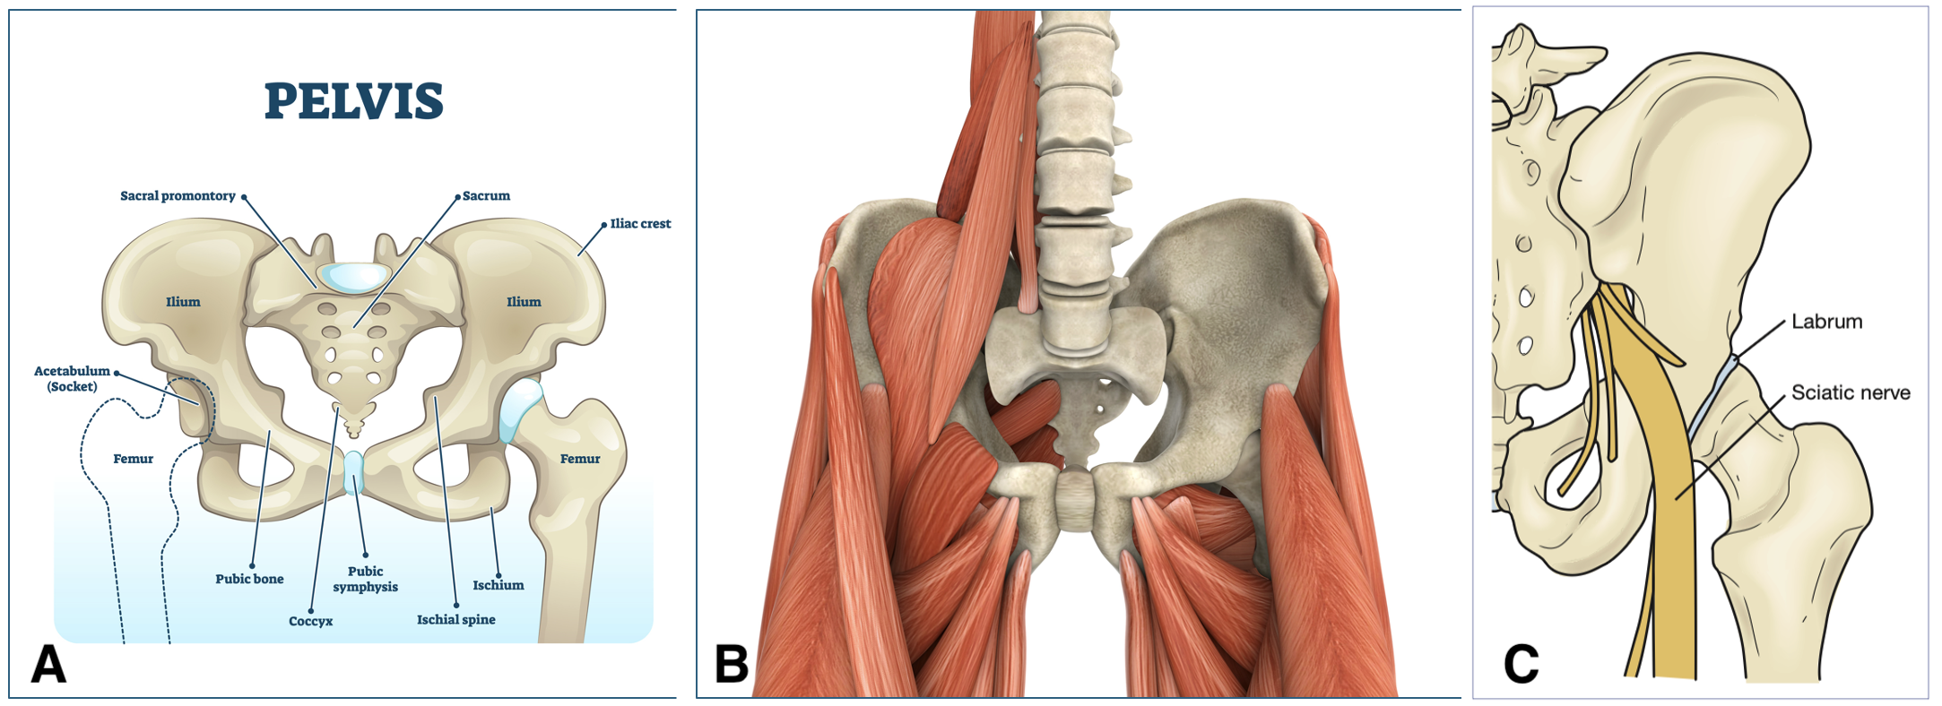

**FIGURE 54.2:** Arterial supply to the femoral head and neck. Note, most blood is supplied from the deep femoral artery via the extracapsular arterial ring of the MFCA (80% of femoral head) and LFCA. A branch of the obturator artery supplies the posterior femoral head via the ligamentum teres (foveolar artery).

**FIGURE 54.3** Posterior hip dislocation via motor vehicle accident. <Previous edition Figure 54.4>

**FIGURE 54.4** Posterior hip dislocation—shortening with internal rotation and adduction of the hip. <Previous edition Figure 54.6>

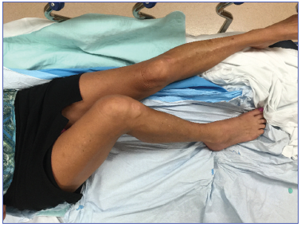

**FIGURE 54.5**Anterior hip dislocation. External rotation, abduction, and extension of the hip. <Previous edition Figure 54.7>

**FIGURE 54.6** Normal anterior–posterior pelvis x-ray. <Previous edition Figure 54.3>

**FIGURE 54.7**Pelvis x-ray showing a subtle right native hip dislocation. Note on this anterior–posterior view the right femoral head is smaller in comparison to the left (*see arrow*) since it is abducted and lies closer to the x-ray plate. Also the lesser trochanter is not well demarcated compared with the contralateral hip. <Previous edition Figure 54.8C>

**FIGURE 54.8 (**A) Pelvis x-ray demonstrating a posterior hip dislocation in a prosthetic hip prereduction and (B) postreduction. <Previous edition Figure 54.8 A and B>

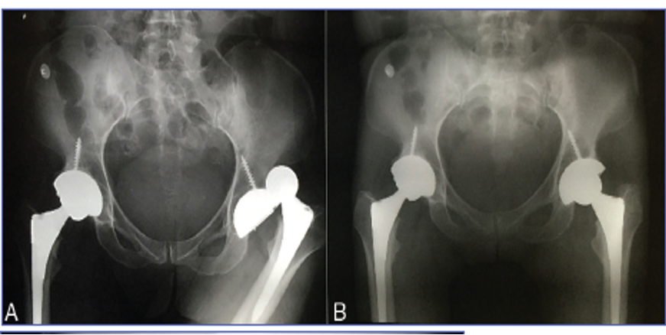

**FIGURE 54.9**Allis technique. <Previous edition Figure 54.9>

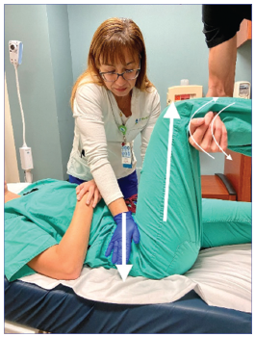

**FIGURE 54.10**Whistler technique**.** <Previous edition Figure 54.10>

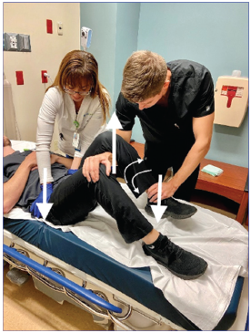

**FIGURE 54.11**Captain Morgan technique. <Previous edition Figure 54.11>

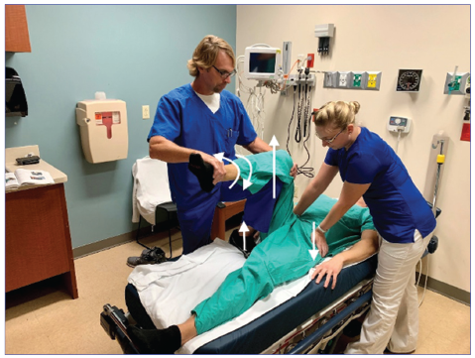

**FIGURE 54.12**Bigelow maneuver. <Previous edition Figure 54.12>

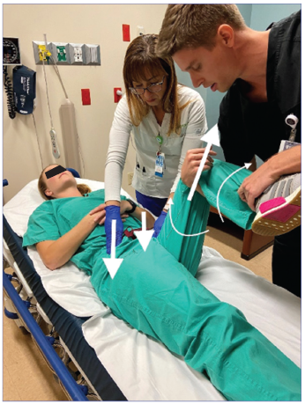

**FIGURE 54.13**Howard maneuver. Note that an additional assistant may be necessary to stabilize the pelvis. <Previous edition Figure 54.13>

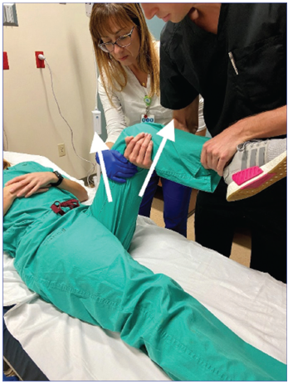

**FIGURE 54.14 Piggyback/rocket launcher technique.** <Previous edition Figure 54.14>

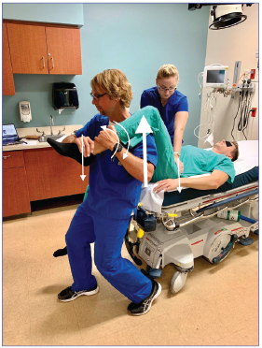

**FIGURE 54.15** Knee immobilizer placed immediately after successful reduction to prevent recurrence. <Previous edition Figure 54.15>

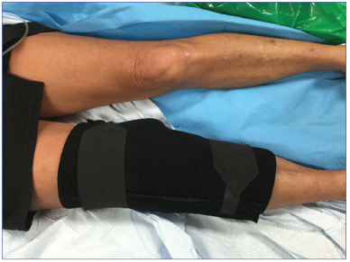

**FIGURE 54.16** Sciatic nerve injury secondary to a traumatic posterior hip dislocation. Note associated posterior acetabular rim fracture. <Previous edition Figure 54.5>

